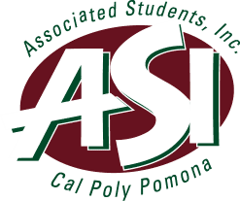

Academic Senate
2-17-16

Nyla Simjee
Secretary of Education

- Senate Resolution in Support of Undocumented Student Success
  - Authored by ASI Vice President Diana Ascencio and ASI Senator at Large, Multicultural Council, Karen Romero.
  - The resolution states that the ASI Senate formally supports undocumented students’ success as participants in society and in the Cal Poly Pomona community.
  - In addition, the resolution advocates for an AB540 liaison that dedicates at least 10% of his or her time to focus on undocumented students’ success and advocacy, that there be Ally Trainings held twice a quarter, that there be serious consideration of a DREAM resource center which will offer undocumented students a safe haven on this campus, and that President Coley and the University Cabinet include the incorporation of a DREAM Resource Center in the campus strategic plan as well as in the facilities master plan.
- President’s Investiture
  - Student leaders were asked to participate in President Coley’s investiture.
- Alternative Transportation Fair
  - Will take place on 2/25/16.
- Sustainability Committee
  - TGIF (The Green Initiative Fund) application guidelines have been finalized.

